User Documentation

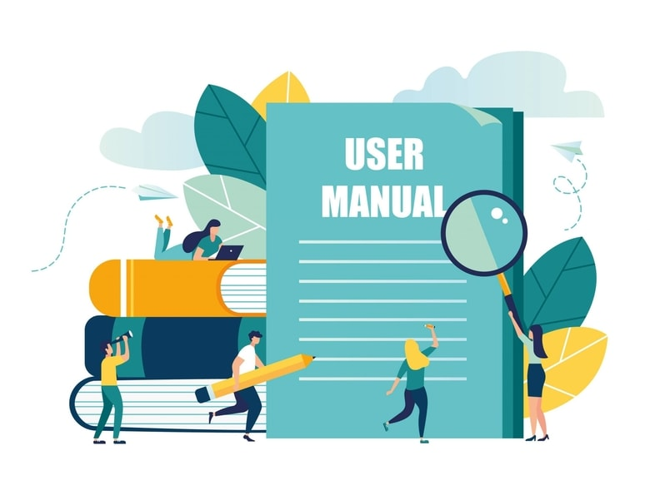

Group Members: Leighton Morgan(620152945), Damelia Coleman(620158703) and Eryka Manning (620155958)

The University of the West Indies (Mona)

COMP1161 - Introduction to Object - Orientation Programming

Due Date :

## **Overview of Traffic Ticket System**

This operation system helps the users create tickets and helps the offenders view the tickets that they have received. A list of all the tickets that were issued out and the individuals that received them.

This software allows the user to indicate if they are a citizen or a JCF admin as well as allowing them to login, create a new account and create a new password.

The application allows for two types of accounts:

* **Citizens**

They are able to:

* + See the tickets they have received. They can only see their tickets alone.
  + See the balances of each ticket written to them.
* **JCF Administration**

They are able to:

* Create new tickets
* Edit the court date and/or name of the offenders on the tickets that they have handed out, if there was a mistake.
* See all the tickets that are handed out.

## **Launching of JCF Traffic Ticket Database**

When launching the application the user will be greeted with a welcome screen that says Welcome To The JCF Traffic Ticket Database and they are able to choose whether they are citizen or JCF Administration. After they indicate whether they are a citizen or JCF Administration, the user is now able to login.

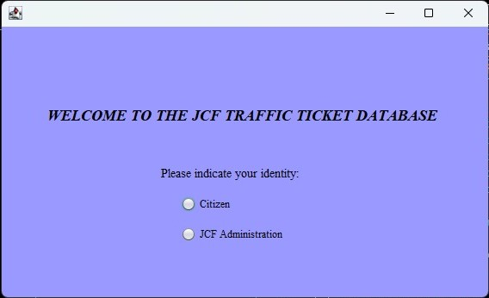

There is not much difference between the citizen login and JCF Administration. The only difference is that the citizen login there is a button that is used to create a new account. After login the difference between the citizen and JCF Administration is shown as they execute various tasks.

### **Citizen**

If the user selects that they are a citizen then they will be led to a screen that asks them for their login information such as name and password. If the user did not remember their password they are able to create a new password.

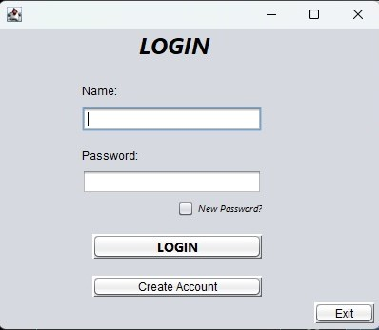

If the user does not have an account they are able to create a new account by pressing the create account button. They will be then led to the Registration Form for Ticket Database.

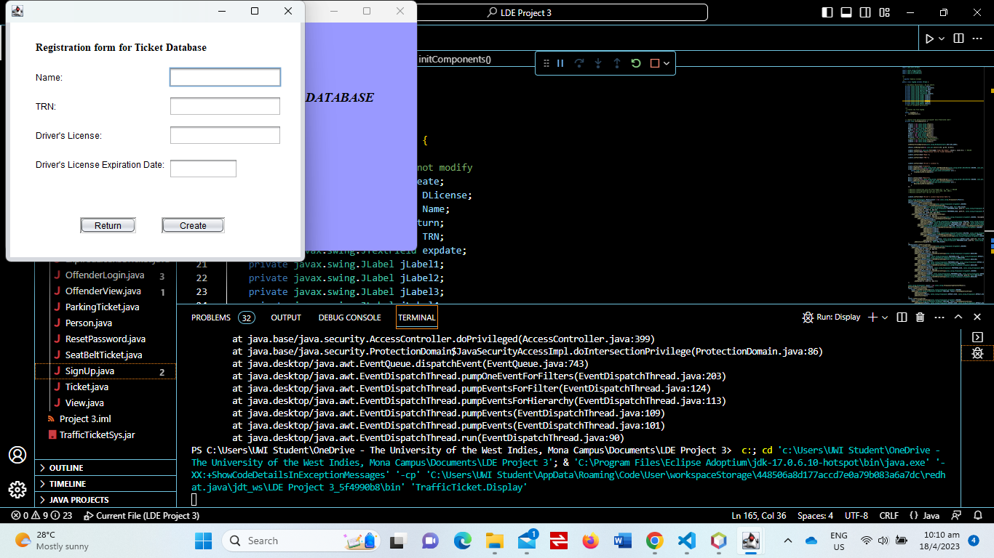

The user will fill out the necessary information. The TRN that the user puts in will become their login password.

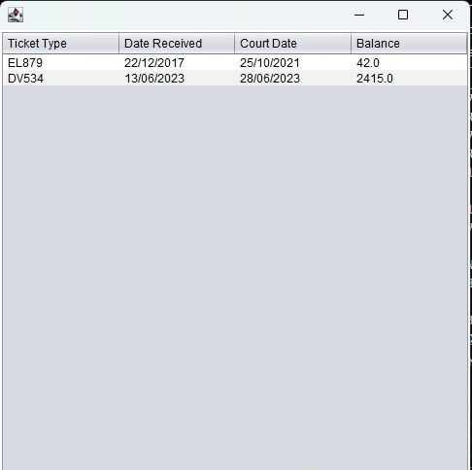

After the user successfully login into his or her account. They are now able to see the tickets that they have received and the balance for each ticket.

### **JCF Administration**

If the user indicates that they are a JCF Administration. Then they will be greeted with a login screen where they will be asked to enter their name and password. If the user does not remember their password they are able to create a new password.

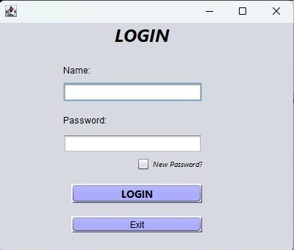

When the incorrect name or password is entered a show dialogue message box appears on the screen indicating that the name or/and password is incorrect.

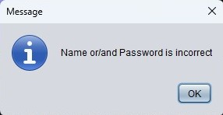

When the correct information is added in the login. It then leads to the main menu where the user can create tickets, edit tickets and view tickets that have been already created.

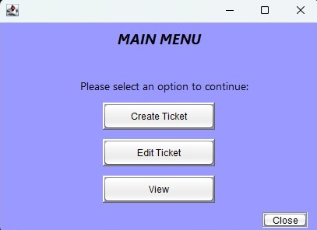

When the user selects **Create Ticket**, it will lead them to the Ticket Form. The user will then fill out the Ticket Form with the necessary information such as Name of the offender, Court Date, Type of Vehicle and Ticket ID. The letters in Ticket ID represent the type of ticket the offender is receiving.

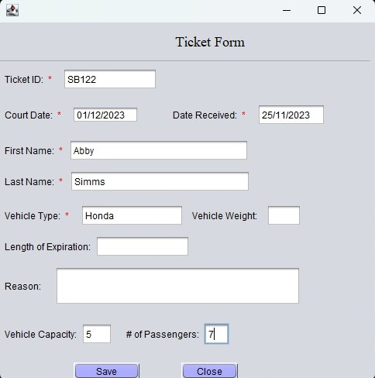

When a User selects View , they are able to view all tickets that were handed out, they can sort by Ticket ID, they can sort by court date and delete offenders from the list.

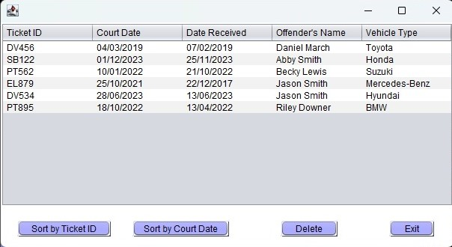

When the user selects the **Sort by Ticket ID** button, the tickets are sorted in alphabetical order. This is shown in the image below.

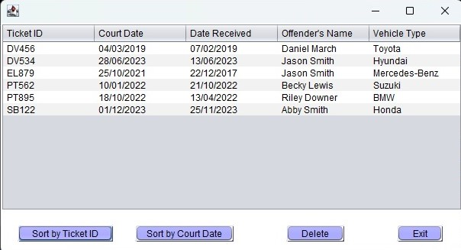

When the User selects the **Delete** button is clicked, the last ticket or latest ticket is removed.

* The image below shows the list before the delete button was used.

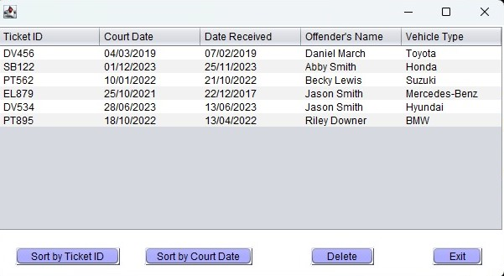

* The image below shows the list after the delete button was used.

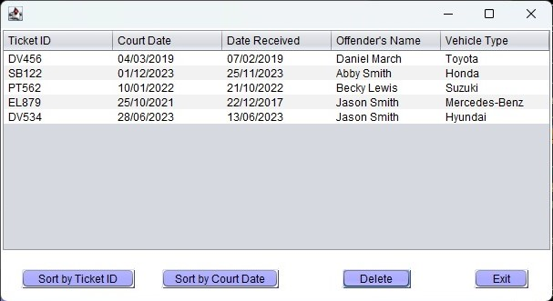

When the User selects Edit Ticket, they are able to edit and update tickets. The user has to enter the Ticket ID that they would like to edit or update.

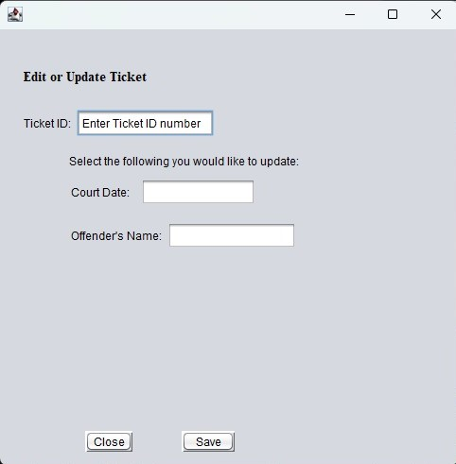

* **Changing Court Date** - the user put in the date that he or she would like to change and then saves the information

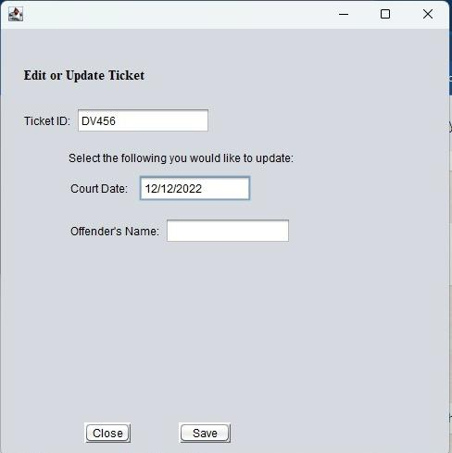

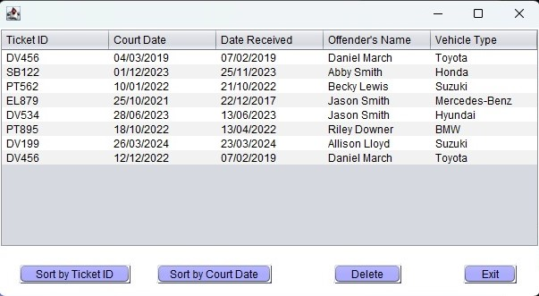

* **Changing Offender’s Name** - The user puts in the Ticket Id that they want to make the changes to. They would then save the information that they have put in.

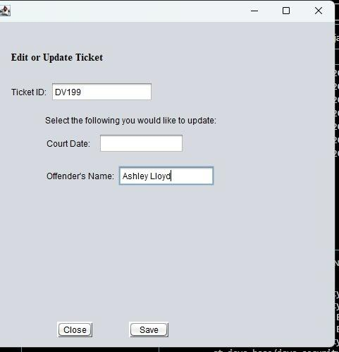

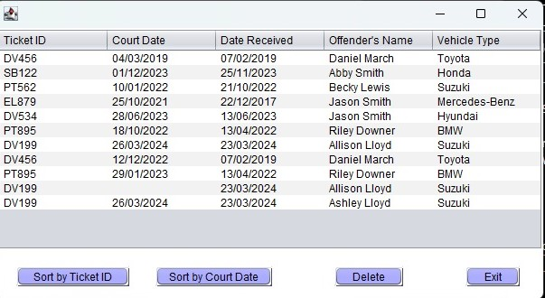

**References**

Brown, J. (2023, March 28). *8 Tips For Writing Better User Documentation*. Helpjuice. Retrieved April 17, 2023, from <https://helpjuice.com/blog/user-documentation>